LAB # 1

Introduction to GitHub

# OBJECTIVE

Introduction to GitHub by creating Git repository and cloning its configuration to eclipse project

Create account on GitHub. 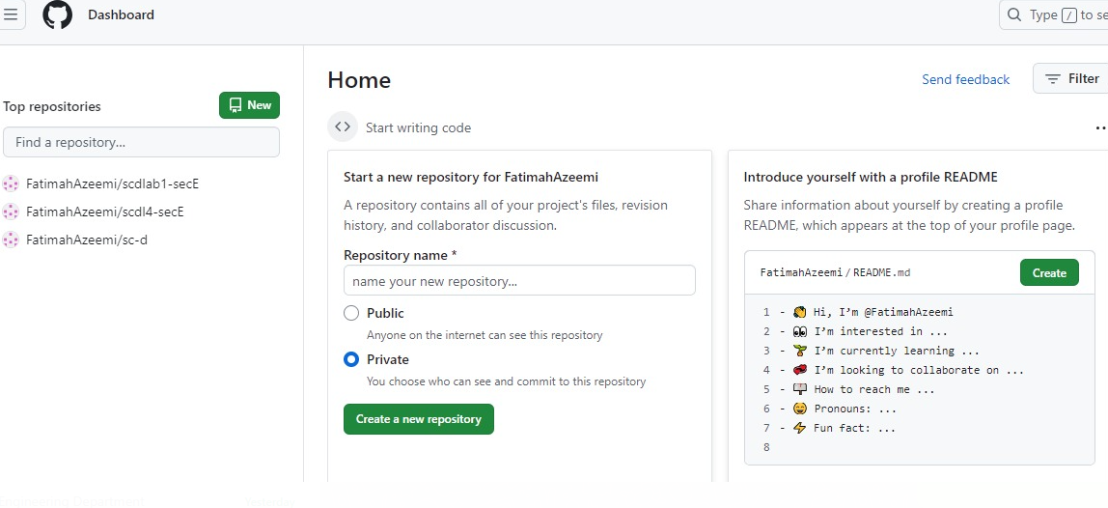

Upload any of your Java Project files and perform commit, push, pull and merge operations.

# Step:01

Step :02

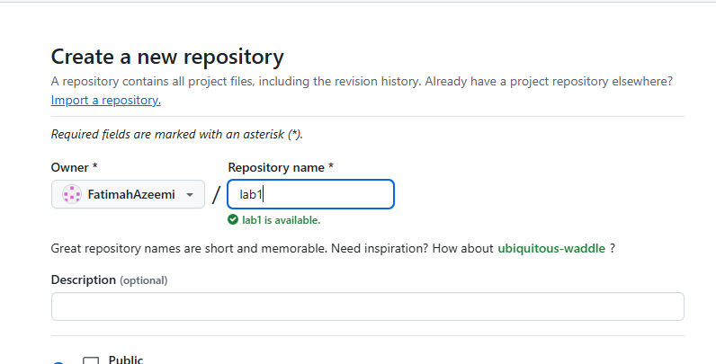

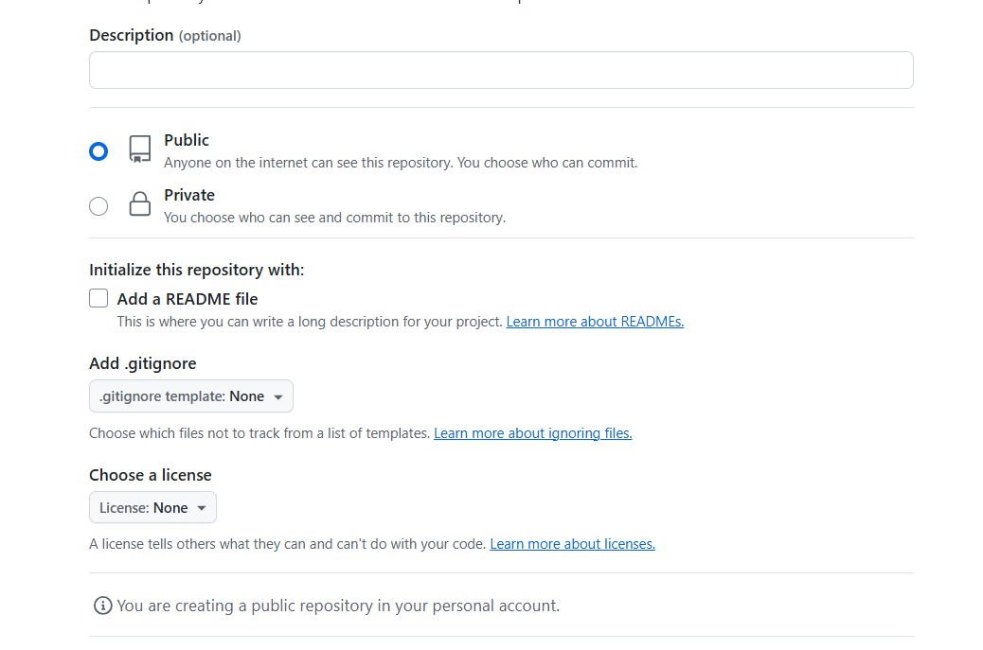Step:03

Step:04

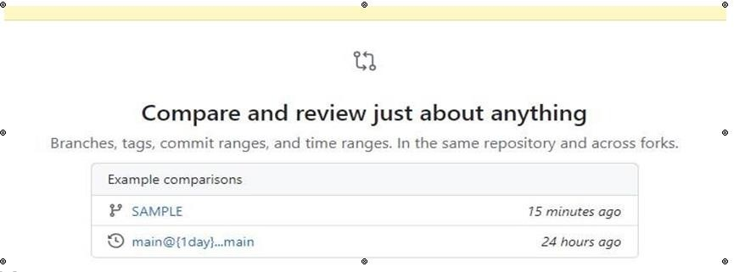Step:04

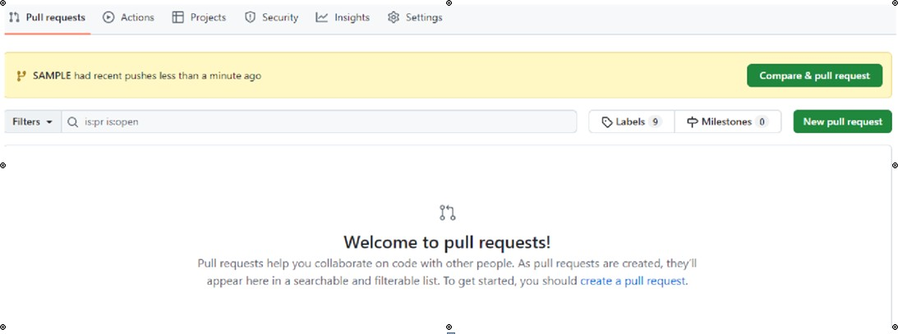Step: 05

Step:06

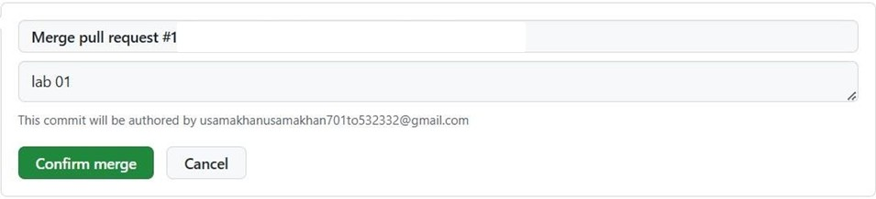

Step:07

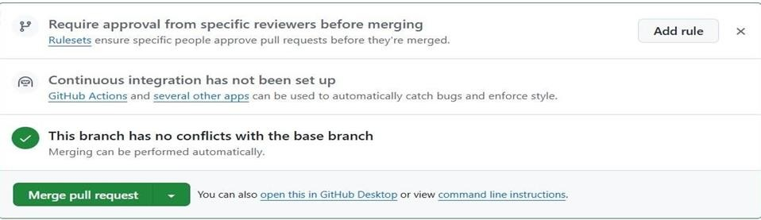

Step:08

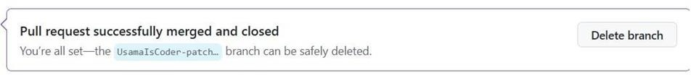

Create account on GitHub.

